Original Method

Online Topology

Offline Topology

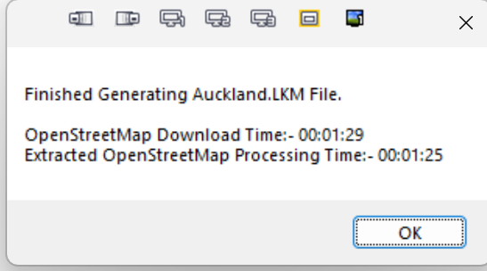

Offline Original

Offline OSMConvert

Online



